## DFS example

Let's see how the Depth First Search algorithm works with an example. We use an undirected graph with 5 vertices.

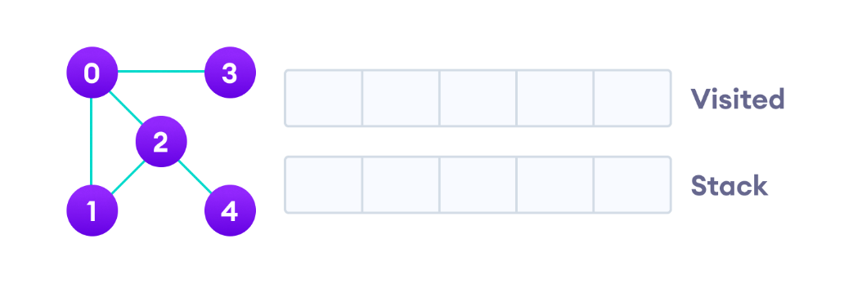

Undirected graph with 5 vertices

We start from vertex 0, the DFS algorithm starts by putting it in the Visited list and putting all its adjacent vertices in the stack.

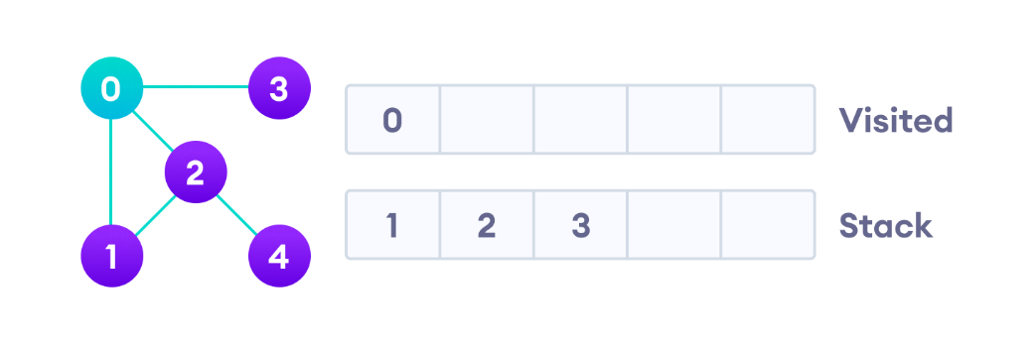

Visit the element and put it in the visited list

Next, we visit the element at the top of stack i.e. 1 and go to its adjacent nodes. Since 0 has already been visited, we visit 2 instead.

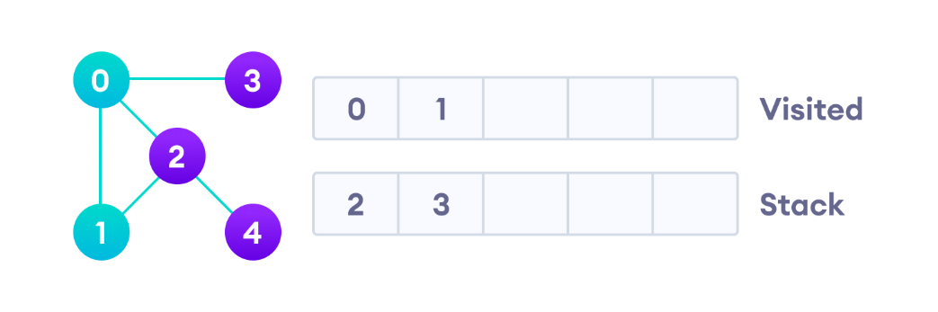

Visit the element at the top of stack

Vertex 2 has an unvisited adjacent vertex in 4, so we add that to the top of the stack and visit it.

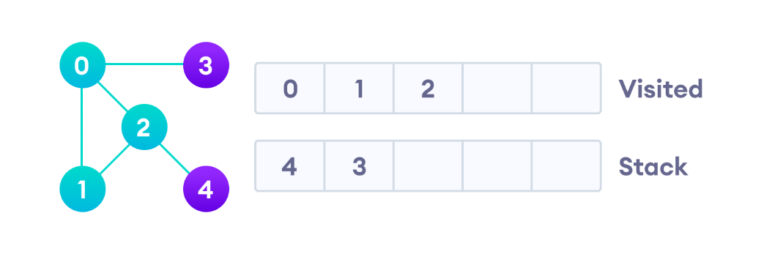

Vertex 2 has an unvisited adjacent vertex in 4, so we add that to the top of the stack and visit it.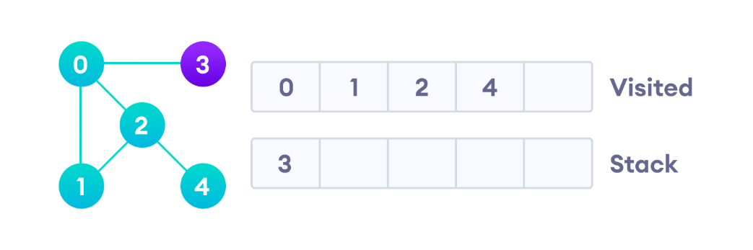

Vertex 2 has an unvisited adjacent vertex in 4, so we add that to the top of the stack and visit it.

After we visit the last element 3, it doesn't have any unvisited adjacent nodes, so we have completed the Depth First Traversal of the graph.

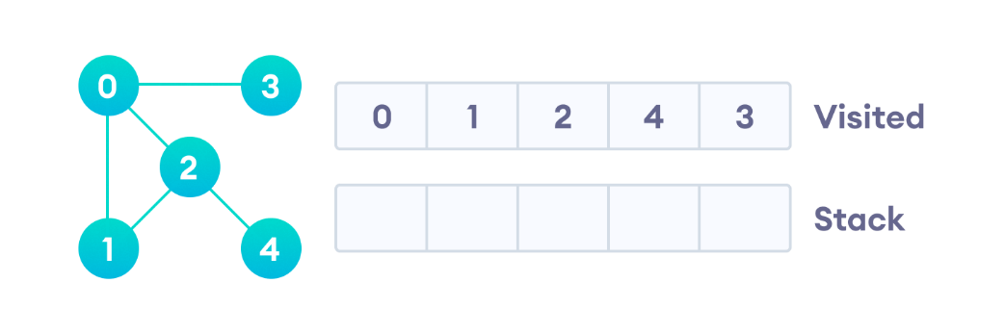

After we visit the last element 3, it doesn't have any unvisited adjacent nodes, so we have completed the Depth First Traversal of the graph.